**Unit testing:**

* Unit testing is the process of testing the individual parts or small parts of system to ensure that
* Individual parts of the system/program works properly.
* While developing a system there are possibly multiple developers working on the system and they are assigned different section of the system to design so when they design their portion / module they test it to ensure it works properly. This type of testing is Unit testing.
* It is done by developers.

**Integration Testing :**

* Integration testing is the process of testing which is performed after integrating different units.
* It is tested along with SRS document where there are specified customer requirements ,if the integrated system has those requirements fulfilled then integration testing is passed [integration testing is conducted to evaluate the compliance of a system component with specified functional requirements]
* Types of integration testing:  
  big bang: kamse kam 2-3 units suruma combine ani test
  + Top-down: jsko priority sabse badi xa tyo vako wala lai suruma
    - For example: student management sytem xa ani teha fees wala criteria sabse highest xa vne payroll sytem hola teslai suruma test grne
  + Bottom-up: bigband ko ulto
  + Mixed (sandwich): top-down + bottom-up

**System testing**

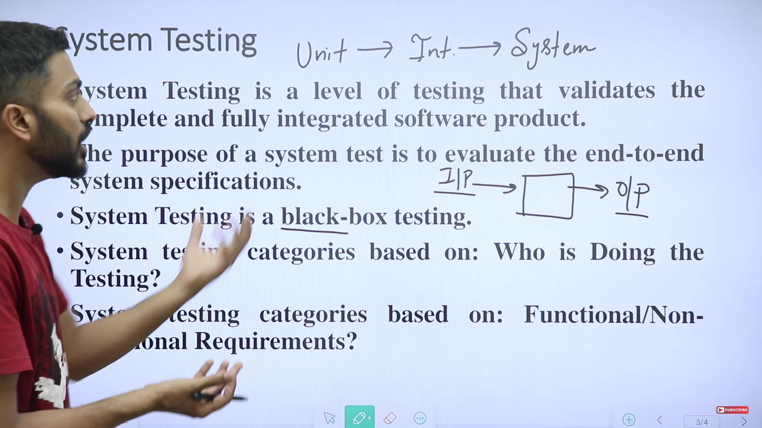

**Who is doing testing :**

Alpha : developers who develop the system (purae sytem banyo aba input dida k output auxa vnerw purae banisakesi ekchoti tw herxa ) Kei kuramilenw vne tiniharu le feri vitra ko program mani change grxan

Ex: movie banyo ani director haru le movie banne bitikae hereko jsto suurma

Beta : developer ko afnae sathi haru huan skxa je vanneni product release vyesi customers nae tw ho eniharuni

They can be external user groups, actual customers or even employees in the same company. This is done in an actual production environment.

Ex: movie banepxi actress huan skxa ani usko sathi haru huan skxa

Acceptance testing : end users haru le grxa

**Nonfunctional requirements/performance testing:**speed: response time of the system(how fast the system is responding)

Scalability: how many customers are there in the system and measure if we increase the number of customer in the system then will the system will work properly or not

Load testing: carried out to determine the behavior of a system or software product under extreme load

Example: if we are working with 2mb database and in some point in future 20mb database is given, will our system can handle that?

Stress testing: errors are imposed in system intentionally by testers to check how the system will work with errors ( jani bujerw afae stress dine)

Security : test if unauthorized users attempt to enter in the sytem then will the system can maintain its security or not

Recovery: How the system recover from errors dataloss or anyother circumstances

Eti lekhde enough